Restorative Pain Management New Patient Questionnaire
Name: __ ___________________________________________________Date: _____ Age: _______
Date of Birth: ___________________Social Security_____________________________________
Address: ___________________________________________________________________________
City: _____________________________________________ State: _____ Zip: ________________
Phone: ________________________Email: _________________________________________Gender: M F
Please provide an emergency contact name and phone number where we may leave a message:
Name: _________________________ Relationship: ___________ Phone: ___________________
Primary Care Provider: _________________________ Referring Provider: ___________________
Please list your current insurance provider(s)
Primary Insurance: _________________________ID #: _________________Group #: __________
Secondary Insurance: ______________________ ID#: _________________Group #: _________
Is there pending litigation associated with the pain? Workers Comp Personal Injury
Car Accident
PAIN HISTORY
Approximate Date that pain began: ______________ Chief Complaint: ____________________
How did your pain start? ___ ______________________________________________
Have you been treated by another pain doctor in the past? Yes No
Doctor’s Name: ____________________________________________________________________
Have you received any previous pain injections? Yes No
Please choose the word(s) that best describes your pain:
SHARP SHOOTING STABBING BURNING TINGLING/NUMB OTHER
What activity brings on the pain or makes it worse? _____________________________________
What eases or eliminates the pain? ____ _____________________________
Is your pain getting better, worse, or staying the same? ___________________________

Where is your pain? Please mark “x” on the drawings in the areas where you feel your pain



Rate your overall pain: No Pain 0—1—2—3—4—5—6—7—8—9—10 Worst Pain Ever
Prior Treatment for Pain: Mark any imaging or treatments performed below.
- MRI of the ______________________ Date: ___________ Facility: ______________
- X-Ray of the ________________ Date: ________ Facility: ______________________
- CT of the ________________ Date: ______ Facility:
- DEXA/ Bone Scan _______________ Date: ___________ Facility: _____________
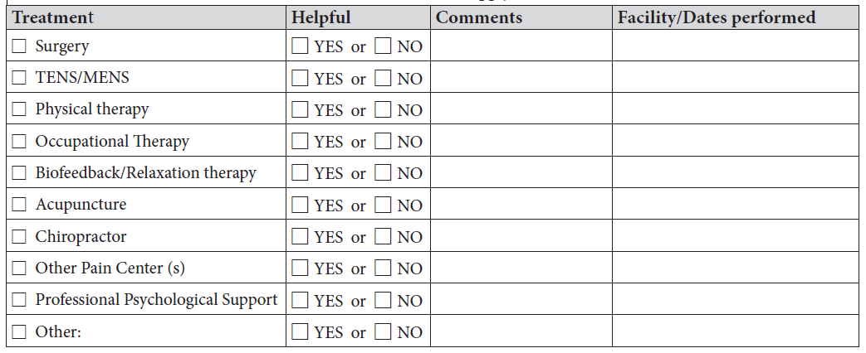MEDICATIONS
List medications with dosage (include any prescribed, over the counter, and/or vitamins): ________________________________________________________________________________________________________________________________________________________________________________________________________________________________________________________________________________________________________________________________________________

Allergies to Medication
Medication Name: | Reaction:
Preferred Pharmacy (Name and Location): ______________________________________
Blood Thinner Questionnaire
Do you take any of the following medications, frequently referred to as “blood thinners”?
If YES, please circle the medication(s) you are taking.
Aggrenox (Aspirin/Dipyridamole) | Eliquis (Apixaban) | Cilostazol
Brilinta (Ticagrelor) | Coumadin (Warfarin/Jan) | Pradaxa (Dabigatran)
Ticlid (Ticlopidine) | Persantine (Dipyridamole) | Effient (Prasugrel)
Pradaxa (Dabigatran) | Pletal (Cilostazol) | Xarelto (Rivaroxaban)
Lovenox (Enoxaparin Sodium) Injection | Aspirin | Fish Oil/Omega 3
Plavix (Clopidogrel) | NSAIDS: Motrin, Advil, Ibuprofen, Aleve, Naproxen, Meloxicam, Relafen, Nabumetone, Voltaren, Diclofenac, Celebrex | Other:

PAST MEDICAL HISTORY
Surgical History: List all surgical procedures related to your pain, year and surgeon that performed them
______________________________________________________________________________________________________________________________________________________________________________________
__________________________________________________________________________________________

Medical History: (Check as many that apply)
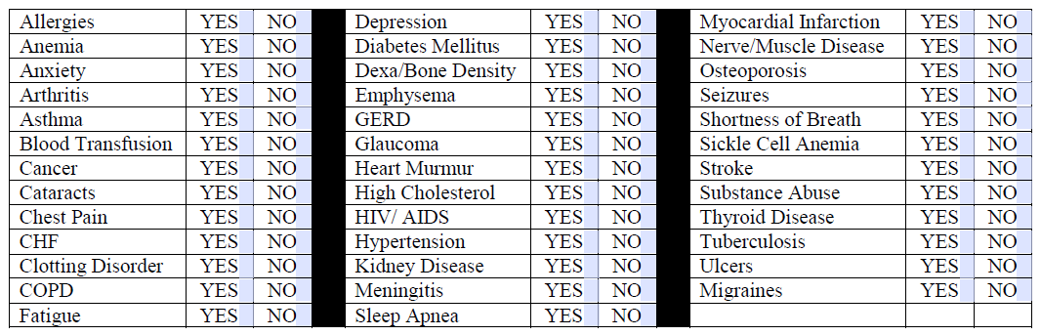
Weight: ______ Height: _____ Last menstrual period: ______ Could you be pregnant? Yes No
SOCIAL HISTORY
Occupation/Occupation prior to Retirement: ________________________________Retired: Yes No
Are you legally disabled? Yes No Are you currently working? Yes No
Marital Status? Single Married Widowed Divorced/Separated Domestic Partnership
# of Children: ________________ Do you have a support system at home? Yes No
Race: Caucasian African American Hispanic Asian Other: _______________
Alcohol Use? Yes No If yes, how many drinks do you have in an average week? _________
Do you have a history of alcohol, or drug abuse? Yes No If yes, how long sober? ______
If yes, what substance was abused? __________________________________________________
Do you manage your pain with illicit drugs? Yes No What type? ____________________
Tobacco Use? Yes No If so, Ready to Quit? Yes No
Smoker: Packs/day ______________
Former Smoker: Quit Date ________ Packs/day__________
Smokeless Tobacco: How Often? ___________
Former Smokeless Tobacco User: Quit Date _________

Code of Conduct for Patients and Visitors
To provide a safe and healthy environment for staff, visitors, patients and their families, Restorative Pain Management expects visitors, patients and accompanying family members to refrain from unacceptable behaviors that are disruptive and/or pose a threat to the rights or safety of other patients and staff.
- If you have any questions about the care received OR are unhappy with the service received in our office, please contact our practice manager before leaving our office.
- Please be sure to communicate all issues that you wish to discuss with the doctor at the time of your appointment. After a visit has ended, another appointment will be necessary to address additional concerns or questions as the doctor works diligently to give all patients the time allocated for their appointment.
- Questions about your billing can be addressed by calling Gateway Medical Solutions
at 573-307-0500.
- Please be courteous with the use of cell phones and other electronic devices. Please minimize volumes or put the device on silent/vibrate when in our office.
- Adults are expected to supervise their children.
- Our practice follows a zero-tolerance policy for aggressive behavior by patients toward our staff.
The following behaviors are PROHIBITED:
- Possessing firearms or a weapon of any kind
- Intimidating or harassing staff or other patients and visitors, including but not limited to using verbally abusive or offensive language
- Making threats of violence through phone calls, letters, voicemail, e-mail or other forms of written, verbal or electronic communication
- Physically assaulting or threatening to inflict bodily harm
- Making verbal threats to harm another individual or destroy property
- Damaging business equipment or property

If you are subjected to any of these behaviors or witness inappropriate behavior, please report to any staff member. Violators are subject to removal from the facility and/or discharge from the practice.
I have read, understand and agree to the Code of Conduct for Patients and Visitors.

Patient/Patient’s representative Name

Patient/Patient’s representative Signature Date

Patient Financial Agreement
I understand that as a recipient of medical care, I, the undersigned, am responsible for all charges regardless of my circumstances for reimbursement. Full payment is due at the time of delivery of service. I understand that a fee is charged for all visits, examinations, or medical reports. I agree that the determination of the professional services to be rendered by my doctor and the fees to compensate him/her for these services are matters which concern my doctor and me. I understand that I have the primary duty and obligation to pay my doctor for his services, notwithstanding any contract I may have with any third-party payer (for example: insurance company, employer, etc).
The undersigned hereby authorizes the release of any and all information or documents to all parties related to obtaining my insurance benefits for claims submitted on behalf of myself and/or dependents. I further expressly agree and acknowledge that my signature on this document authorizes my physician and all necessary parties to submit claims to obtain benefits, for services rendered, without obtaining my signature on each and every claim to be submitted for myself and/or dependents; and that I will be bound by this signature as if the undersigned had personally signed the particular claim.
I hereby authorize my insurance company to pay and hereby assign directly to Pain Management Medical Center, LLC, d.b.a. Restorative Pain Management, all benefits. I understand I am financially responsible for all charges incurred. I further acknowledge that any insurance benefits, when received by and paid will be credited to my account, in accordance with my insurance company’s assignment. Any unpaid charges are my responsibility. Full payment is due at the time of service except if otherwise arranged or mandated by law.
Patient balances are due immediately and are not contingent upon receiving a statement. Insurance companies provide an explanation of benefits outlining payments and patient balances.
Unpaid charges over 60 days will incur a monthly service fee of $25. Accounts with no activity for 60 days may be forwarded for further collection action. If I default and my account is referred to a collection agency or attorney, I will be responsible for all costs of collecting monies owed, including interest, court costs, collection, collection agency (25% of total balance) and attorney fees. Any and all advance collection fees incurred by the practice will be included in my final bill. I understand and agree that some additional charges may come through from my treatments that are not included in the initial estimated bill. There is a $35.00 service charge for a returned check.
I UNDERSTAND THAT IT IS MY RESPONBILITY TO KNOW WHAT THE TERMS OF MY INSURANCE ARE, AND IN COMPLIANCE WITH THOSE TERMS, AGREE TO THE FOLLOWING:
- Providing Pain Management Medical Center, LLC, d.b.a. Restorative Pain Management with complete an accurate billing information, including, but not limited to, a current insurance card, authorization numbers, and/or referrals for each visit and/or procedure. I am responsible for all visits and procedures not properly authorized.
- I will pay all applicable co-pays and outstanding patient balances as they become due. All co-pays and patient balances are due at each visit.
I give my consent to Pain Management Medical Center, LLC, d.b.a. Restorative Pain Management to provide medical care and treatment to the below-named patient deemed necessary and proper in diagnosing or treating his/her/my physical condition.
I HAVE READ AND AGREE TO THE TERMS OUTLINE ABOVE
SIGNED (patient or guarantor): _________________________________________________________
DATE: _______________ FOR (print patient name): ________________________________
AUTHORIZATION TO USE AND DISCLOSE HEALTH INFORMATION
I hereby authorize Dr. Gregory Stynowick/Restorative Pain Management/Restorative Surgery Center to:
- Release my records to (designate below) OR
- Obtain my records from (designate below)
Patient’s full name: __________________________________________________________________
Date of Birth: ________________ Social Security Number: _________________________________
I request only the following information to be released/obtained:
- Clinician office notes
- Laboratory reports
- Diagnostic imaging reports
- Urgent Care records
- All hospital records (including Emergency room and/or operative reports, progress notes, etc)
Date(s) of Treatment: __________________________________________________________________
Records to/from (circle one): Physician/Institution/Self Name: ______________________________
Street Address: _______________________________________________________________________
City: _________________________________ State: _______ Zip Code: ________________
Phone: _________________________________ Fax: _________________________________ For the purpose of: ___________________________________________________________________
I hereby authorize the use or disclosure of my individually identifiable health information as described above. I understand that this authorization is voluntary. I understand that if the Organization authorized to receive the information is not a health plan/provider covered by Federal Privacy Regulations, the released information may no longer be protected by Federal Privacy Regulations.

I permit the release of all information indicated above including, if any, concerning drugs/alcohol treatment, abuse and/or use. Psychiatric treatment or AIDS/HIV and other communicable diagnosis and treatment thereof, and to include any Hepatitis Testing/results.

I understand that this authorization will expire one year from the date listed below.

I understand that I may revoke this authorization at any time by notifying the providing organization in writing, except to the extent the organization has taken action in reliance on the consent. I understand that I may be required to pay the cost of preparing and mailing the copies, except for uses and disclosure for treatment.

__________________________________________________________________ ______________
Signature of patient or patient’s Representative Date

_______________________________________________________________________________________
Printed Name of patient or patient’s Representative Basis of Representative’s Authority

